JD Security Solutions

Jacob Arsenault, Daniel O’Donnell

**Design Document**

**Context Diagram:**

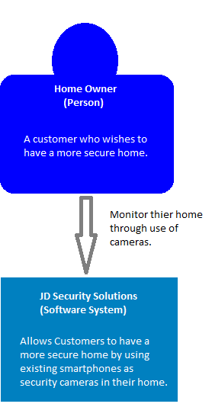

**Container Diagram:**

